**Phase 8: Data Management & Deployment**

**Goal :**

To efficiently manage, migrate, and secure student data and metadata across Salesforce environments using native tools, packages, and modern deployment methods.

1. **Data Import Wizard**
   * Imported sample student records and related data through the Salesforce UI.
   * Validated successful import with list views and reports.
   * Documented mapping fields for reusability.

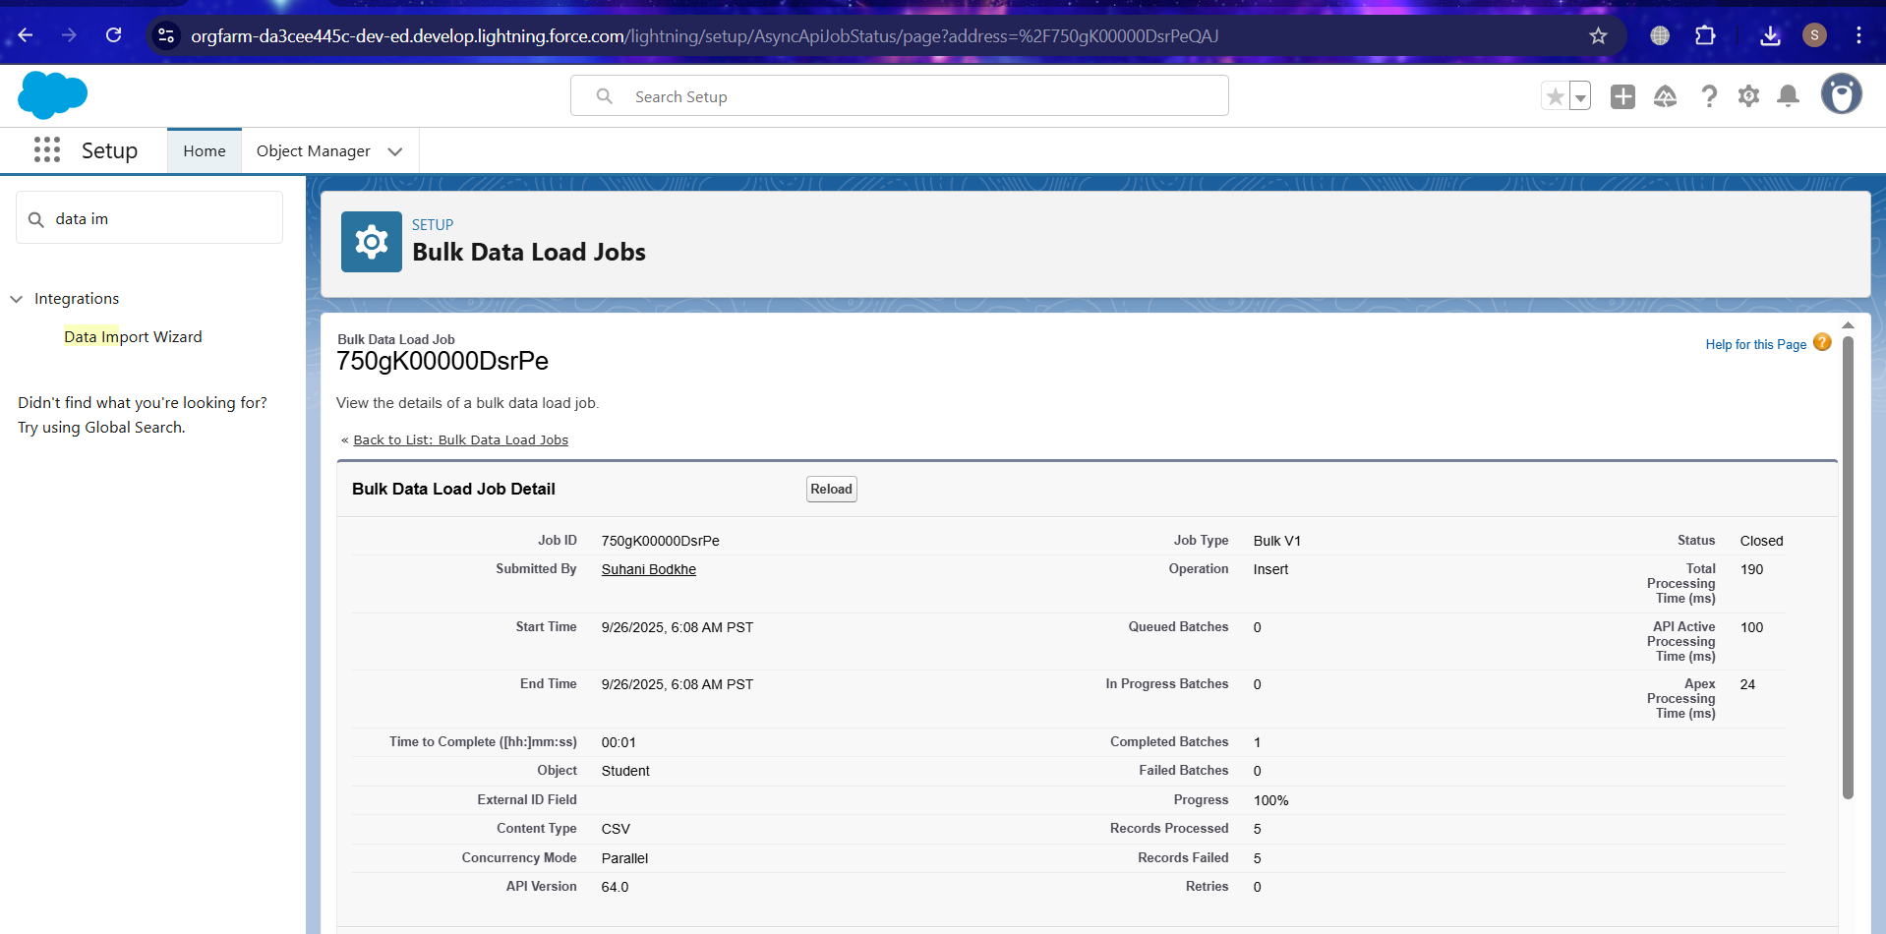

1. **Data Loader**
   * Performed bulk inserts, updates, and deletes for large datasets.
   * Created CSV templates for Student and Course objects.
   * Logged and reviewed success/error CSVs for audit.

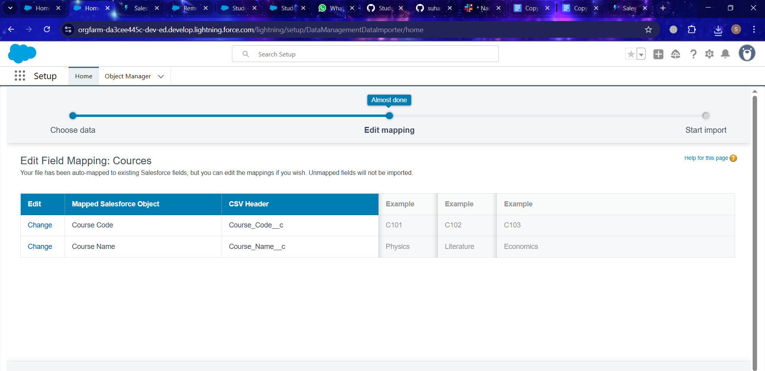

1. **Duplicate Rules**
   * Defined matching rules to detect duplicate student records.
   * Configured duplicate rules to block or allow with alerts.
   * Tested with sample data to ensure data quality.

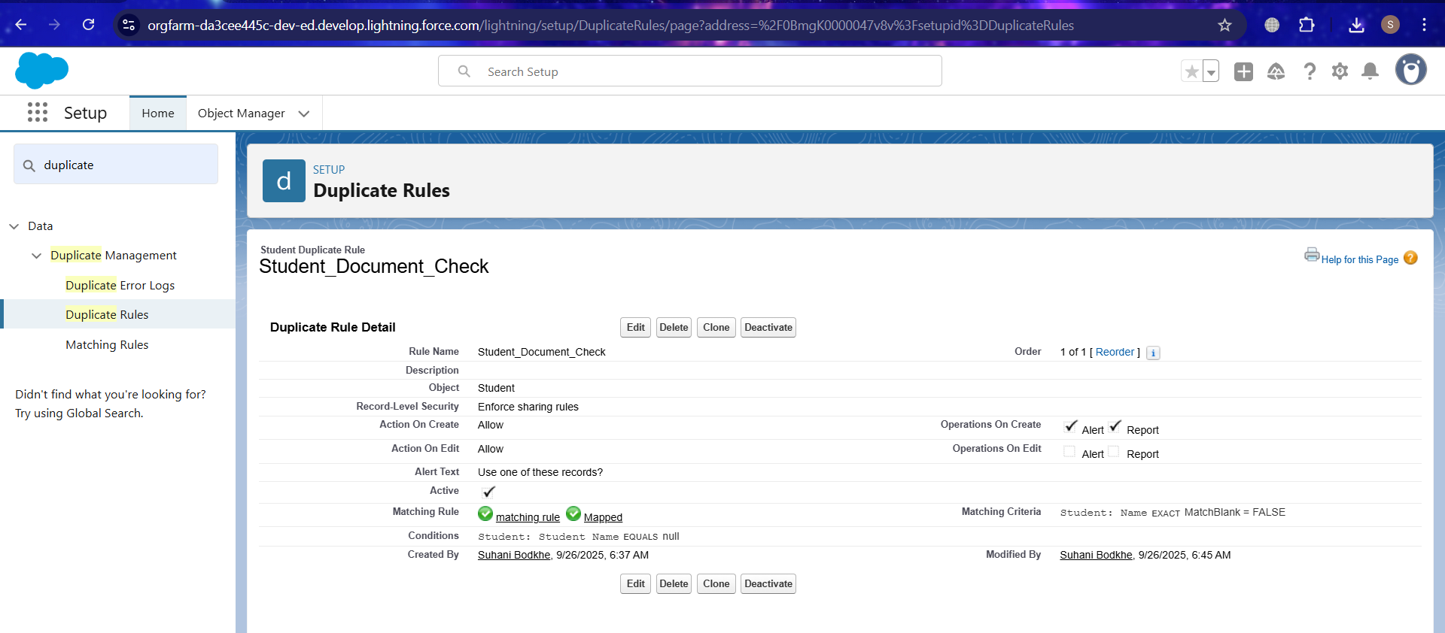

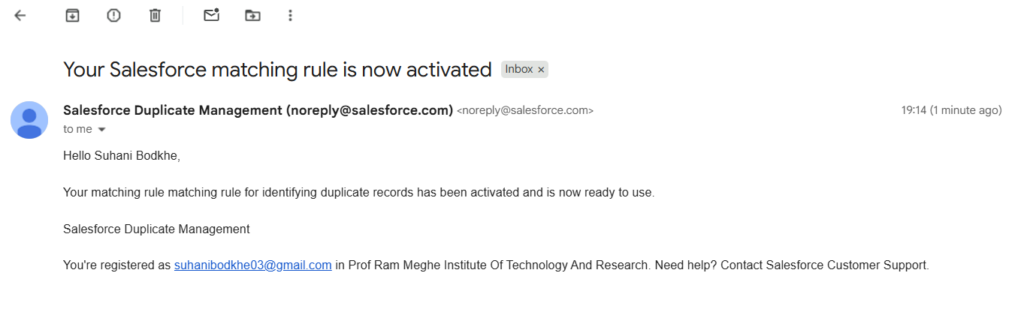

1. **Data Export & Backup**
   * Scheduled weekly data export from Setup for backup.
   * Downloaded CSVs of critical objects (Students, Courses, Enrollments).
   * Stored backup securely for rollback scenarios.
2. **Change Sets**
   * Created outbound change sets with custom objects and fields.
   * Uploaded change sets to target sandbox and deployed.
   * Validated deployment results post-migration.
3. **Unmanaged vs Managed Packages**
   * Built an unmanaged package containing custom objects for sharing.
   * Created a managed package to test namespace and code protection.
   * Installed both in a new org and documented differences.

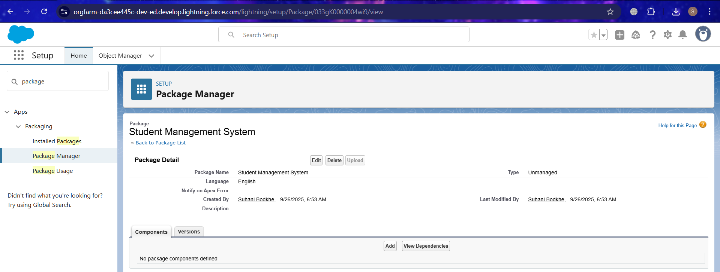

1. **ANT Migration Tool**
   * Configured build.xml and package.xml for metadata retrieval.
   * Retrieved custom object and Apex class metadata from source org.
   * Deployed changes to target org and validated success logs.
2. **VS Code & SFDX**
   * Set up VS Code project with Salesforce CLI and authorized orgs.
   * Retrieved metadata using sf project retrieve start.
   * Modified and deployed changes back using sf project deploy start.

